PRESS RELEASE

No.51/SP/TKP-ASEAN2023/04/2023

PUBLIC COMMUNICATION TEAM

Ahead of the ASEAN Summit, Minister of Transportation

Reviews Transportation Readiness in Labuan Bajo

Jakarta, Kominfo Newsroom – Minister of Transportation Budi Karya Sumadi reviewed transportation facilities and infrastructure readiness in Labuan Bajo, East Nusa Tenggara (NTT), Wednesday, ahead of the 42nd ASEAN Summit on 9-11 May 2023.

He reviewed several points, such as Komodo Airport, Marina Bay Pier, and the tourist area in Tana Mori, as one the activity points.

"I want to ensure that transportation facilities and infrastructure are ready to serve the mobility of leaders and delegates participating in the ASEAN Summit, both to and from Labuan Bajo and local mobility in Labuan Bajo," said the Minister of Transportation in a statement received in Jakarta, Wednesday, 26 April 2023.

He also explained several preparations to support the smooth mobility of the ASEAN Summit participants, namely preparing operations and facilities at Komodo Airport and other airports, such as Denpasar, Surabaya, Lombok, Kupang, and Jakarta.

The preparations are capacity management, aircraft parking stands, flight slots setting from and to Labuan Bajo, setting domestic and international routes, and installing communication media as markers such as banners, backdrops, stickers, and other communication media.

In addition, the Directorate General of Air Transportation of the Ministry of Transportation will also increase the frequency of flights to and from Labuan Bajo a week before the main event. It is to support the movement of committee mobility, event-supporting stakeholders, logistics, and add personnel/HR on duty at Komodo Airport.

Furthermore, the Ministry of Transportation's Directorate General of Land Transportation and the NTT Province Transportation Service has also prepared several traffic engineering measures to expedite the movement of vehicles around the event area and within the event area.

In addition, it also adds road safety facilities such as public street lighting, guardrails, water barriers, delineators, traffic signs, and markings.

Then, they provide three bus stops and 25 Hiace-type buses as shuttle transportation for delegates, committees, and journalists with 30 driver crews.

The Minister of Transportation considered the ASEAN Summit in Labuan Bajo a good momentum to introduce tourist destinations to guests from ASEAN countries and the world.

"Hopefully, Indonesia's chairmanship at the ASEAN Summit can run smoothly and be successful, just like when Indonesia was chairing the G20 meeting last year in Bali," said the Minister of Transportation. (Bernardy/TR/Elvira)

***

Director General of Public Information and Communications of the Ministry of Communication and Informatics – Usman Kansong (0816785320).

Get more information at https://infopublik.id.

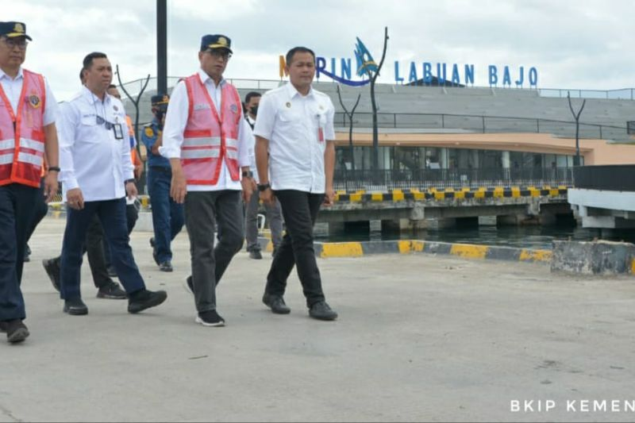

Minister of Transportation Budi Karya Sumadi (second from right) inspects Marina Bay Pier in Labuan Bajo, NTT, Wednesday, 26 April 2023, ahead of the 42nd ASEAN Summit. ANTARA/HO-Biro Komunikasi dan Informasi Publik (BKIP) Kemenhub

